Ahsanullah University of Science and Technology

Course title: Numerical Technique & Laboratory
Course No: EEE 3110 Sessional

Project Name: Vehicle Number Plate Detection Using MATLAB (App Designer)

Submitted To:

Ms. Sharmin Sobhan Safayat-Al-Imam
Assistant Professor of Dept. of EEE Assistant Professor of Dept. of EEE
Ahsanullah University of Science & Technology Ahsanullah University of Science & Technology

Date of Submission: 28th September, 2024

Submitted By:
Students Name: Ahmed Eyenun Nishat
Students ID: 20220105237
Department: Electrical and Electronic Engineering
Section: d1
Group: 3
Year: 3rd
Semester: 1st
Objectives:
The objective of this project is to develop an application can detect and process vehicle license plate images. The application is designed to automatically identify the characters on the license plate and display the plate image.

Equipment/Software:
Software:
MATLAB R2018a: The main software environment used to develop and test the application.
App Designer: MATLAB’s graphical user interface (GUI) to design the user interface. Image Processing Toolbox: A MATLAB toolbox for image manipulation and analysis.

Key functions: readImage showImage findROI findChars
startupFcn

Callbacks:
BrowseButtonPushed:
- Opens a file browser to let the user select an image file (a picture of the license plate). The selected file is then processed by readImage(app), and the images are displayed in the app window using showImage(app).
SelectdisplaytypeButtonGroupSelectionChanged:
- Triggered when the user selects one of the display options (original, grayscale, or black)

Other functions:
Functions Used in the Application:
- imread (): Reads an image file into MATLAB for processing.
- rgb2gray (): Converts the original RGB image into a grayscale image.
- imshow(): Displays images in a GUI axis.
- uigetfile(): Allows the user to select a file from the file system.
- sum (): Sums the values along a matrix's rows and columns to identify regions of interest (ROI).
- find (): Finds the indices of non-zero elements for processing rows and columns of the image. - diff (): Computes the difference between adjacent elements in a matrix, helping to identify changes in regions of interest.
- imresize (): Resizes the images for comparison during character recognition.

Procedure:
1. Flowchart: - Start
- Select an image: The user browses and selects a license plate image file.
- Image reading: The app reads the image and stores it.
- Convert to grayscale: The app converts the image to grayscale for further processing.
- Convert to black and white: A threshold is applied to convert the grayscale image to black and white. - Find ROI (Region of Interest): The app identifies the section of the image where the license plate is located.
- Extract characters: The app locates individual characters from the ROI.
- Compare with templates: The extracted characters are compared against a pre-defined character template database to identify them.
- Display results: The processed images and extracted characters are displayed in the app's GUI. - End

2. Code Implementation:
The complete MATLAB code includes the user interface components and the underlying logic for image reading, processing, and displaying.

Result:
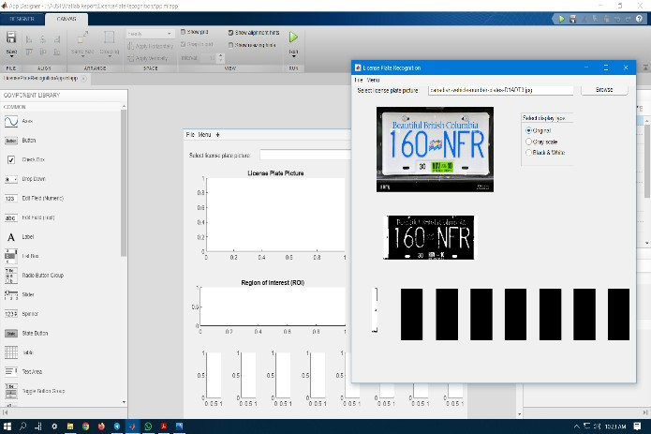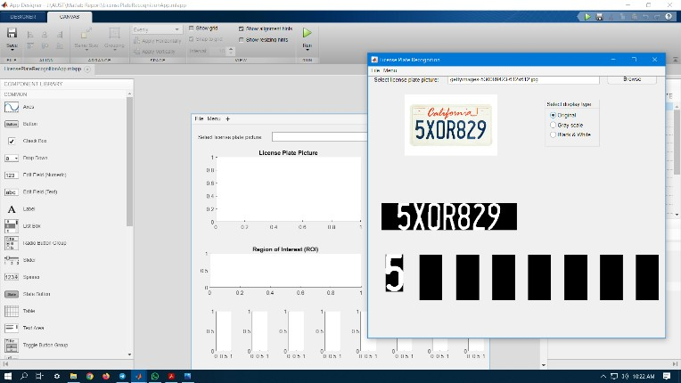

Here we have input an image and the app detects the characters from the number plate.

Screenshots:
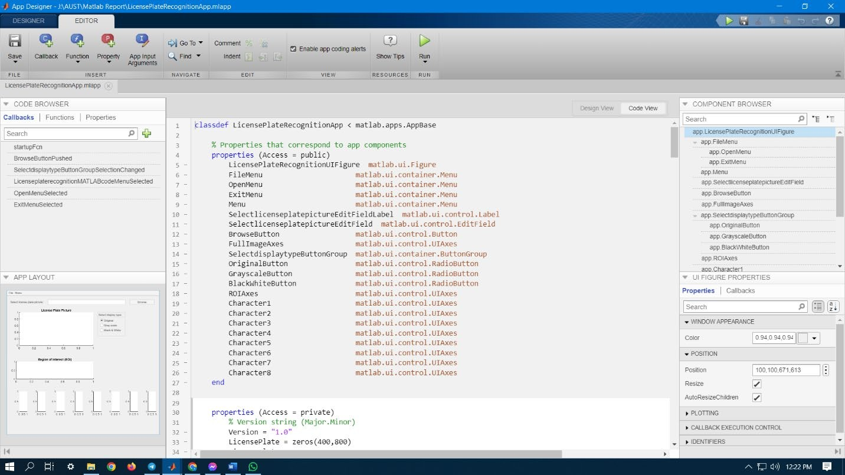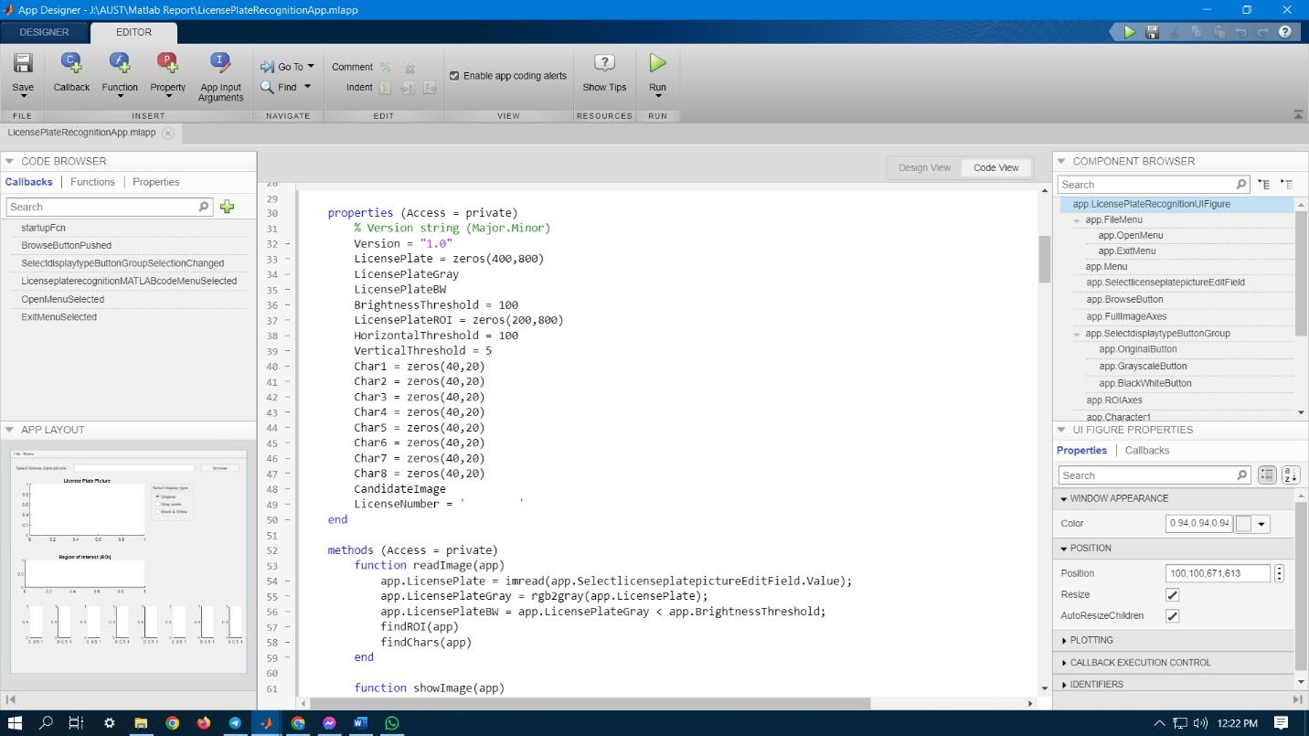

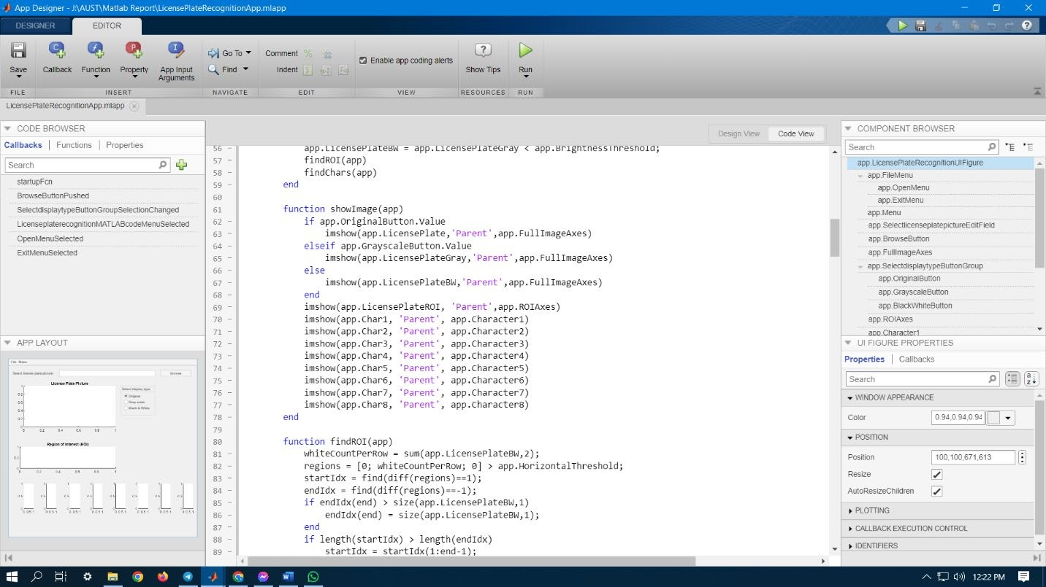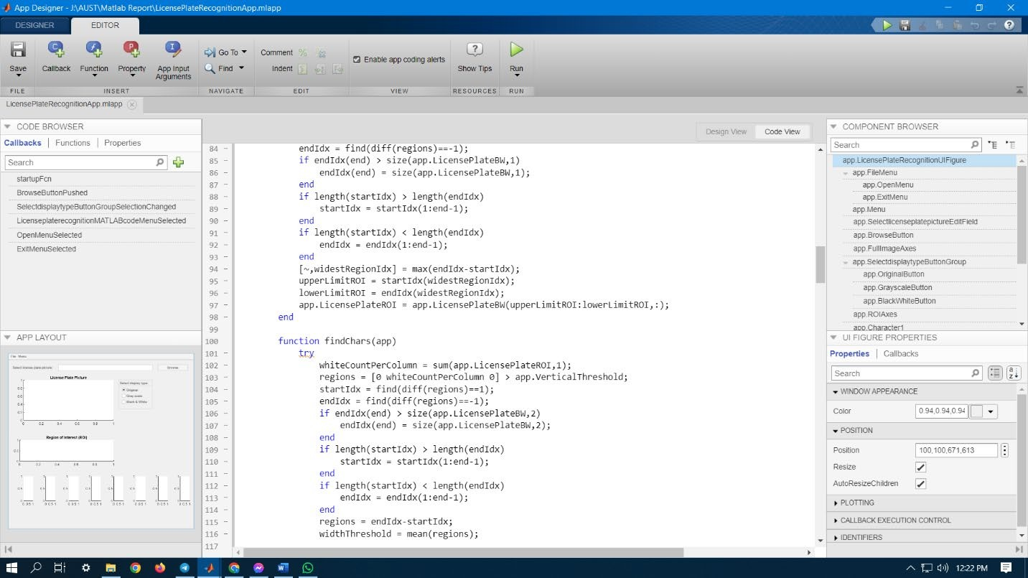
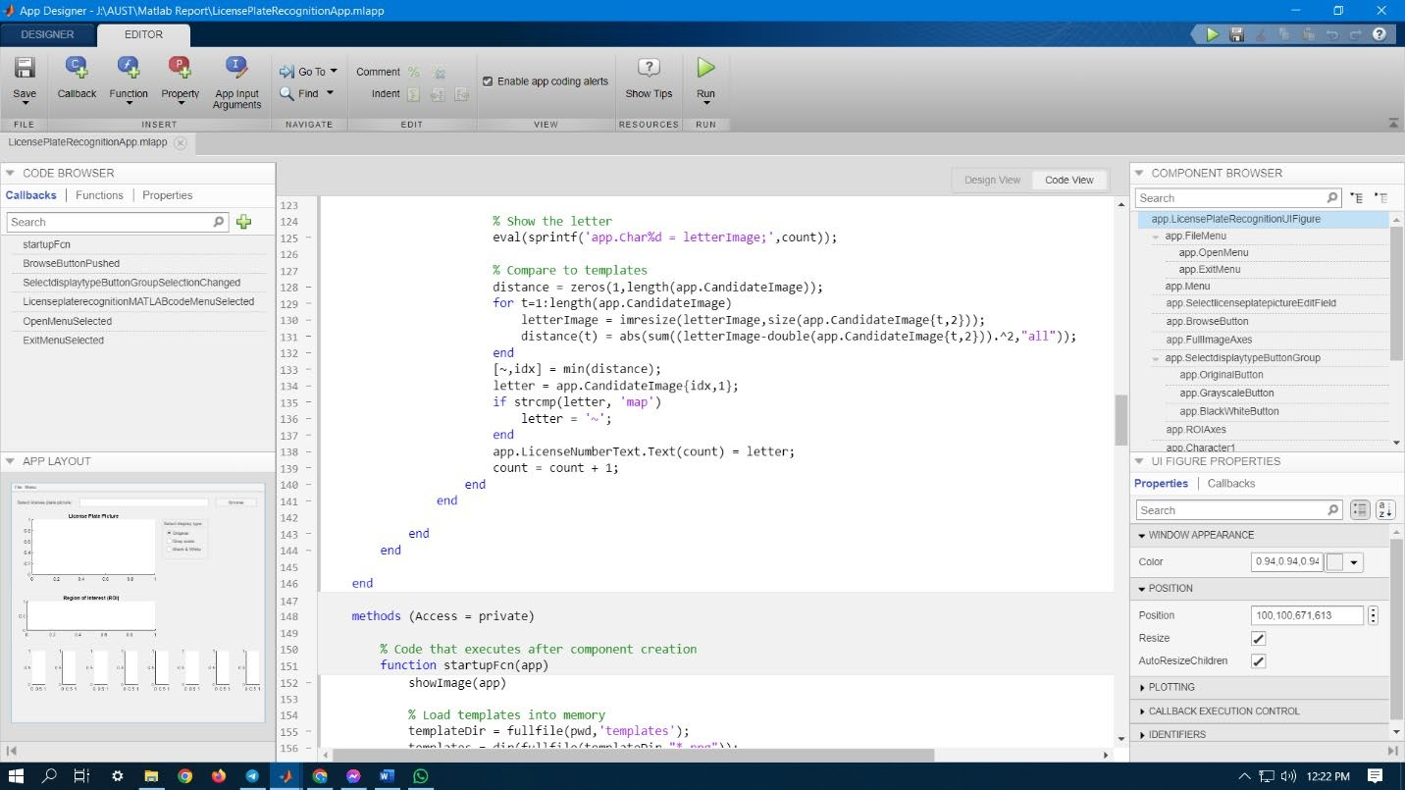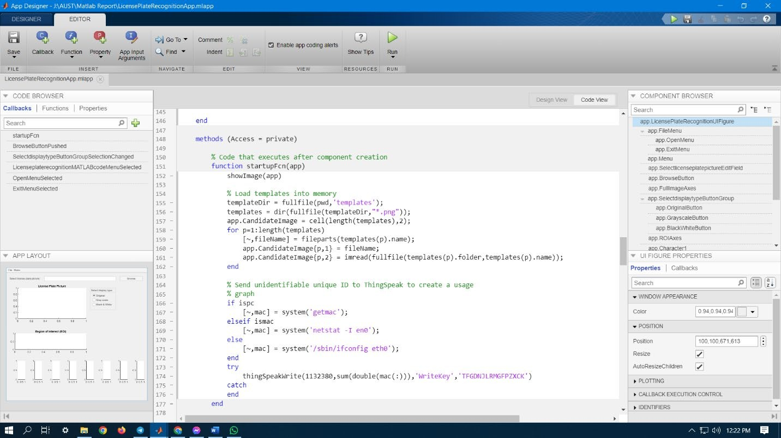
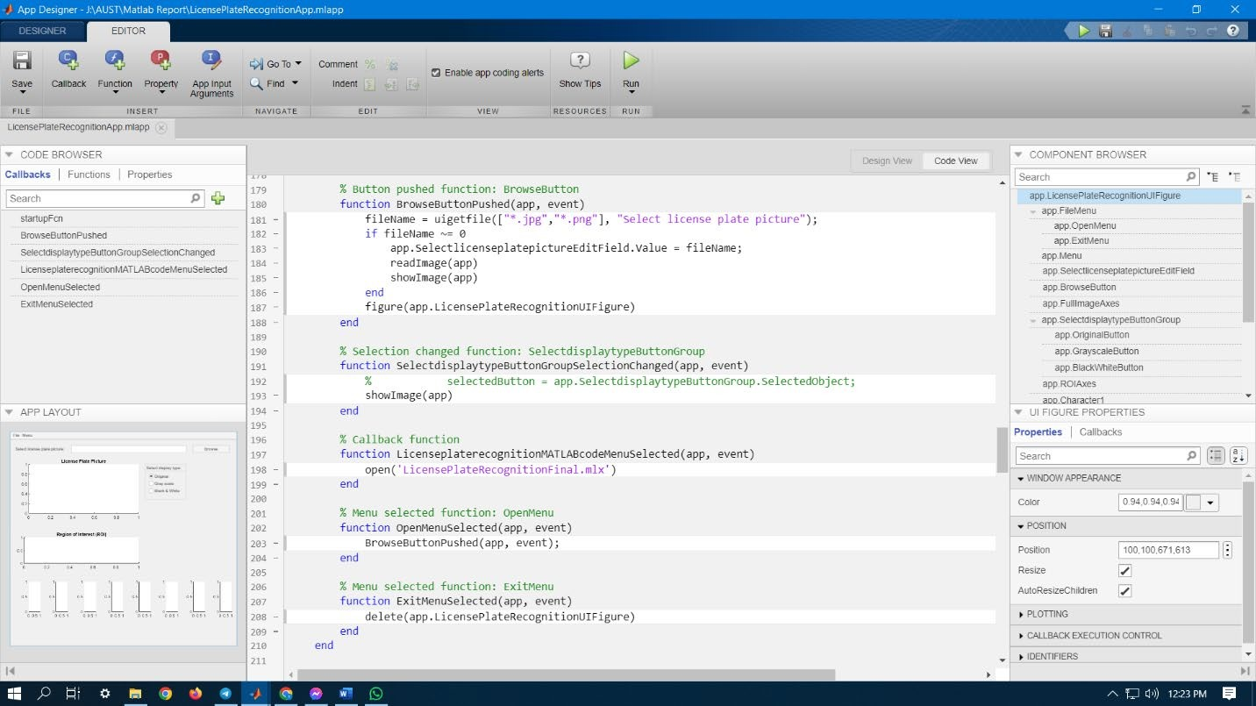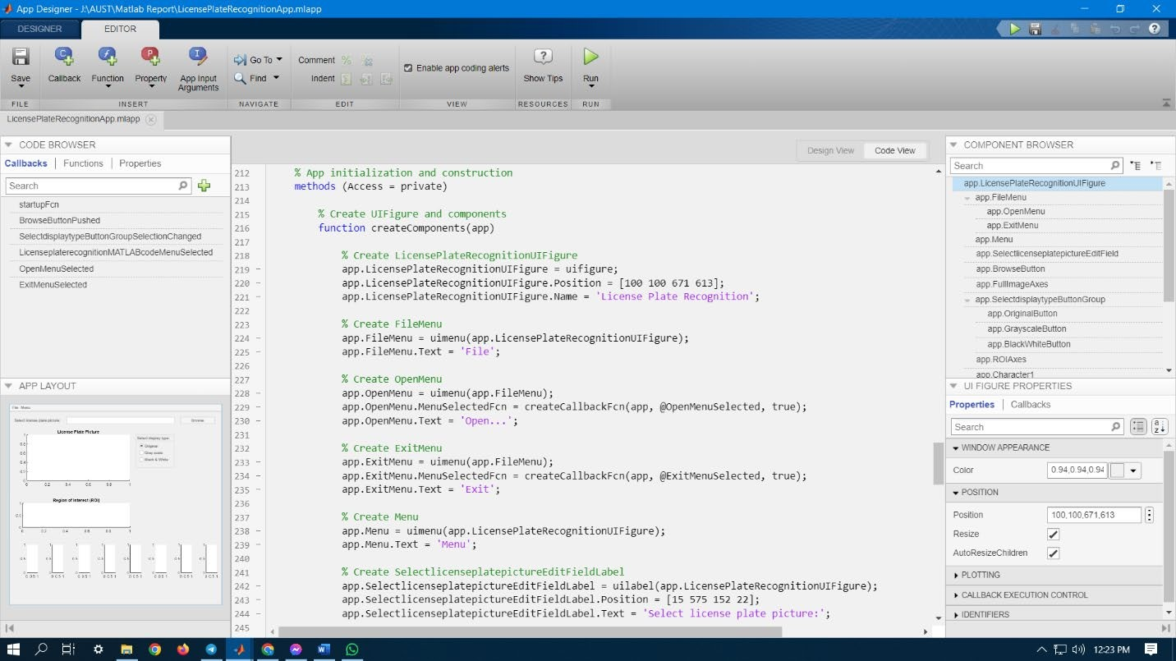
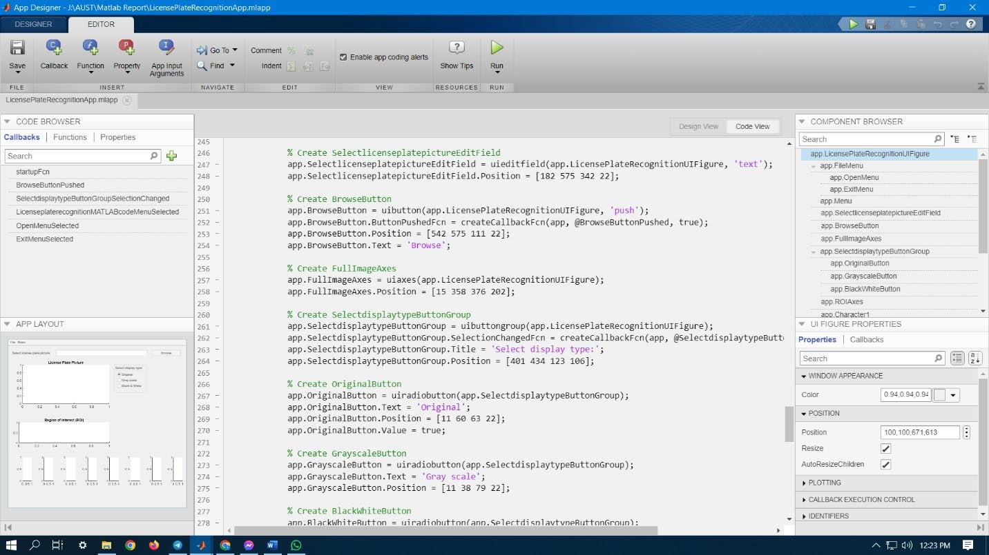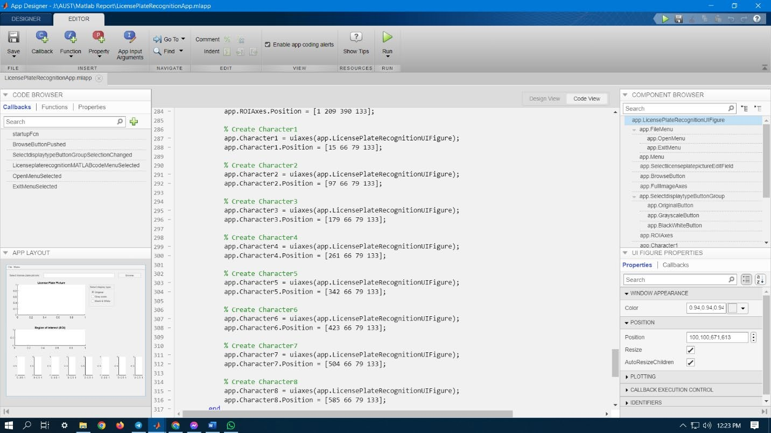

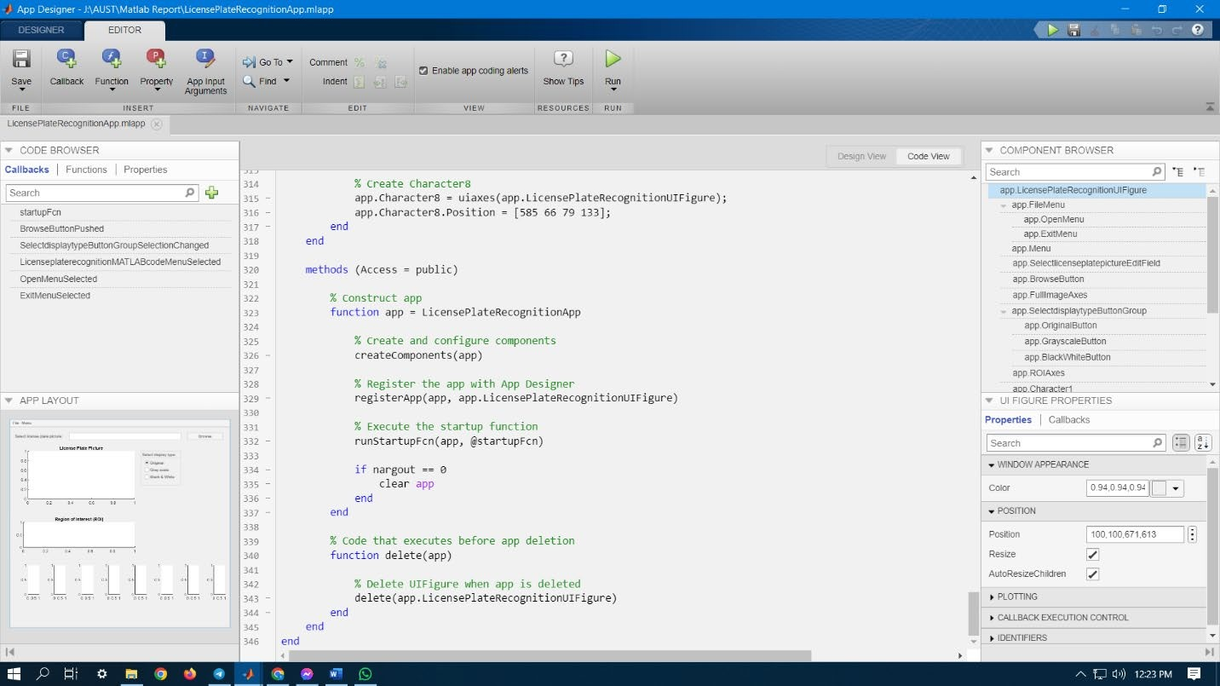

Discussion:
The app successfully processes the image and converts it into different formats and detects the characters. The accuracy of character detection depends on the quality of the images. If the image is too noisy or the characters are not well-defined, the app may struggle to accurately identify.

